
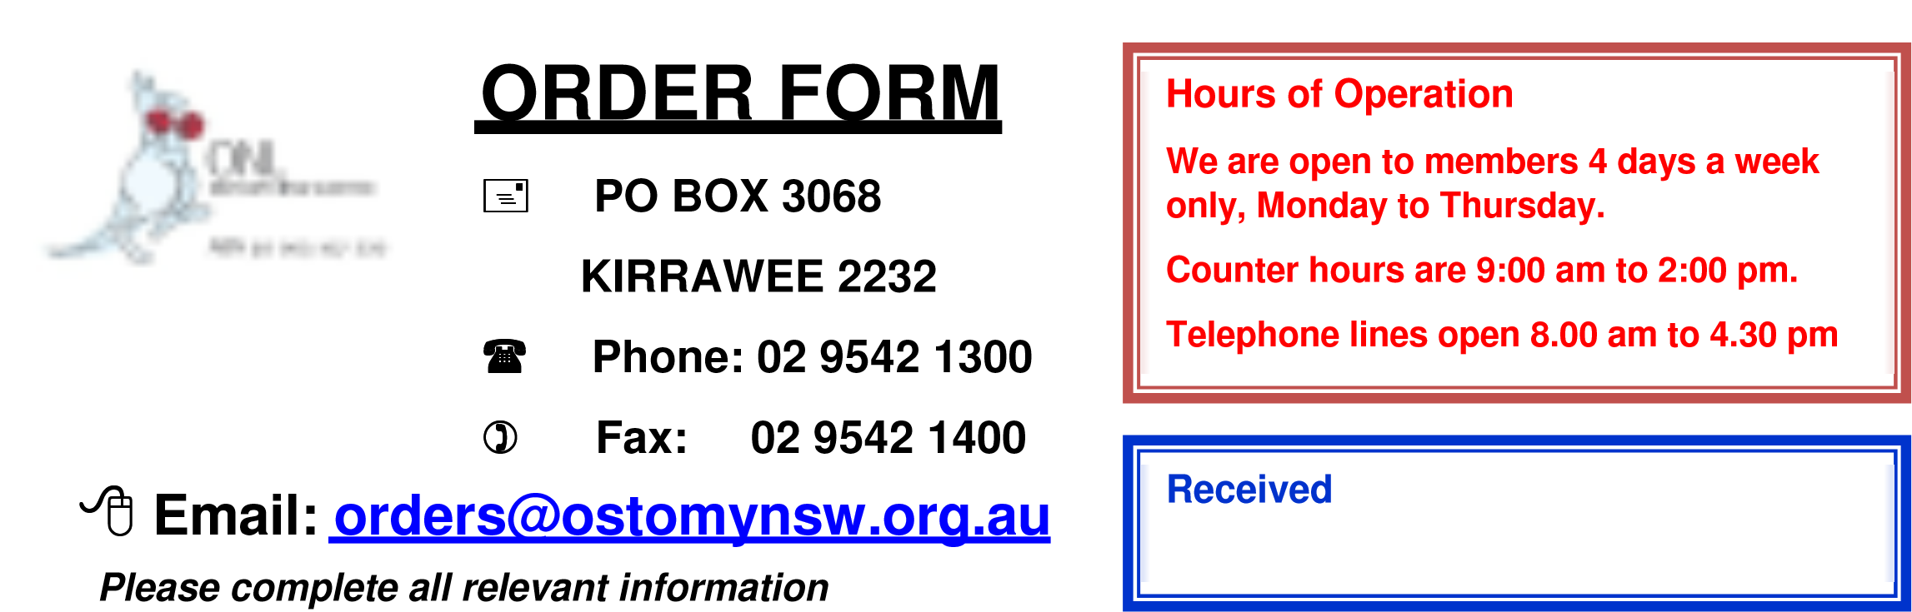
Version: Oct 2021
Name |  |  |  | Member No.
Medicare Number |  | __ __ __ __ __ __ __ __ __ __ __  Ref No. |  | Expiry Date: ___ ___ / __ __ __ __

 |  |  |  |  |  | Delivery Address
 |  |  |  |  |  |  |  |  | Post Code
 |  |  |  |  |  | Delivery Method
Post |  |  |  | Pick up |  | ** NOT CURRENLTY AVAILABLE **
Payment Method (Do not send cash) |  |  |  |  |  |  |  | Amount Paid |  |  |  | $
Cheque Money Order Credit Card Direct Debit Date Paid _____ / _____ / _____
BSB 112-879, Account No. 456643389
Identify this with member number and a word describing the payment (e.g. “Postage” or “Fees” or “Donation”)
Please charge my credit card (minimum $45.00)
(Only Mastercard and Visa are accepted and the minimum amount is equal to 3 postal deliveries)
Name on card |  |  |  |  |  |  | Expiry Date |  |  |  | /
Card No. | / / / |  |  |  |  |  |  |  |  | CVC No. (last 3  digits on back of card)
Brand |  |  | Product Code |  | Description |  |  |  |  |  |  |  |  | Quantity

Write here any supplies to be purchased or any special instructions for delivery of your order:
______________________________________________________________________________________________________________________________________________________________________________________________________________________________________________________________________________Please allow Australia Post up to 10 working days to deliver your order, subject to your location.

